**MOVIES QA SYSTEM PROJECT REPORT**

**Niteesh Nitin Singh**

* **Introduction**

The QA system leverages Natural Language Processing (NLP) and Neo4j Graph Database to provide real-time, natural language query handling for movie datasets. The project aims to address movie-related queries, extract insights, and deliver an enhanced user experience.

* **Platform/System Setup**
* **Environment:** Python 3.12.3 with essential libraries such as Flask, pandas, pymongo, Neo4j, spacy, tqdm, and others.
* **Python IDE:** Pycharm Community version 2023.3.3
* **Neo4j Configuration:** Requires Neo4j running locally with the credential’s user="neo4j", password="bigdata612".

Made few config changes:

* dbms.memory.heap.initial_size=6G
* dbms.memory.heap.max_size=6G
* dbms.memory.pagecache.size=8G
* dbms.windows_service_name=neo4j-relate-dbms-a4ee4310-4e49-49e0-9082-926af4973254

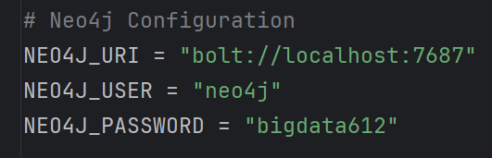

* **MongoDB Configuration:** Local MongoDB instance to store intermediate datasets.

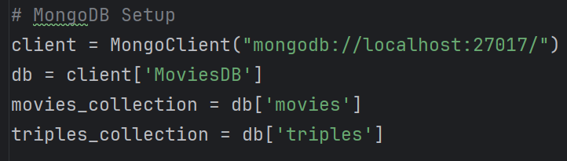

* **CoreNLP Server:** Stanza CoreNLP server for natural language processing tasks.
* Required Libraries: pandas, pymongo, psutil, neo4j, Flask, request, render_template.
* **Setup Procedures**
* Install the required packages: flask pandas pymongo spacy tqdm neo4j stanza
* Set up and run Neo4j locally, ensuring it listens on bolt://localhost:7687.
* Download the Stanza CoreNLP package and specify the path in NLP_triple_extract.py.

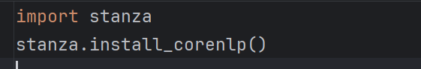 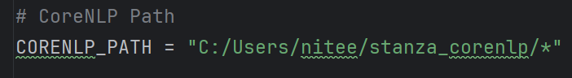

* Load the spaCy model for English: en_core_web_trf

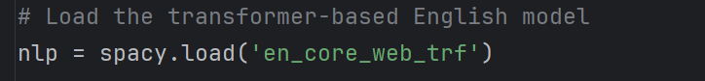

* **Code Analysis**

Each file serves a specific purpose in the project pipeline:

1. **Dataset Cleaning (Dataset_cleaning.py)**

* **Purpose:** Cleans and processes raw movie data.
* **Steps:**
  + Handle missing values in columns like budget, revenue, runtime, etc.

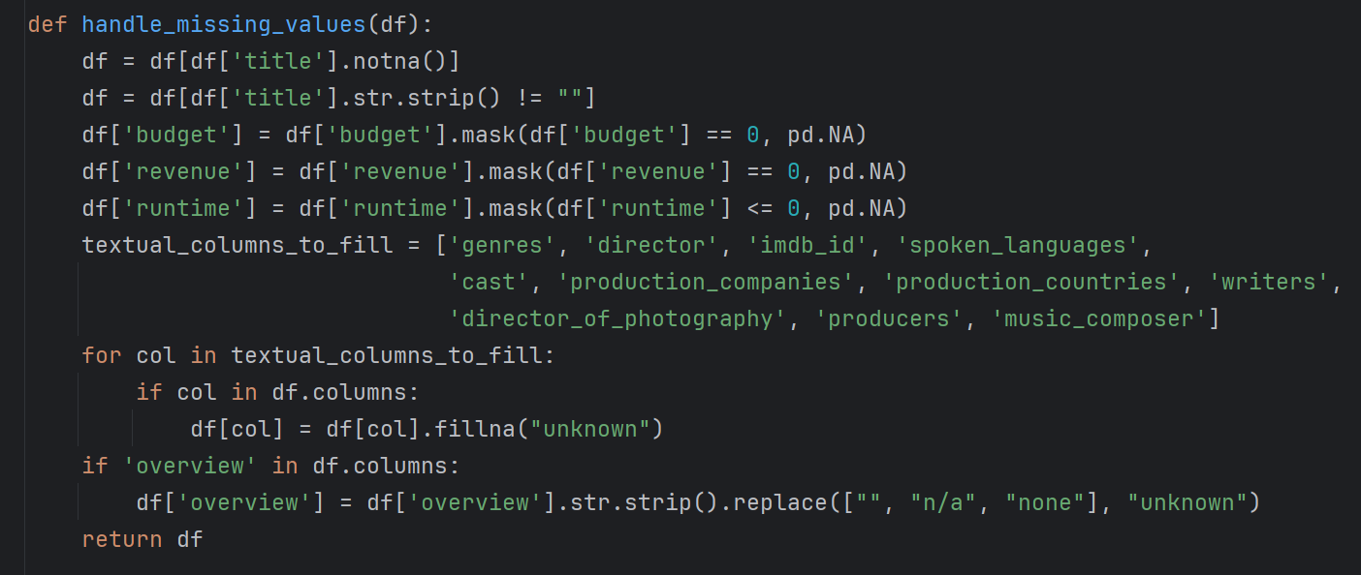

* + Standardize text by converting to lowercase and stripping whitespace.

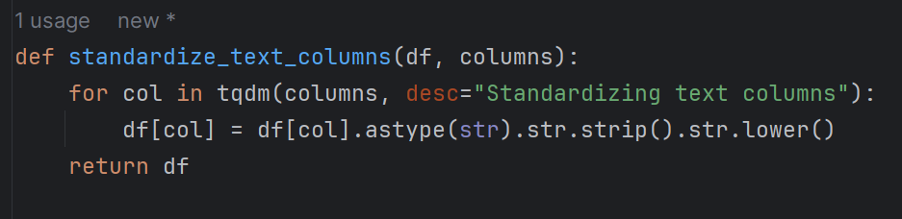

* + Normalize multi-value columns (e.g., genres, cast) by splitting strings into lists.

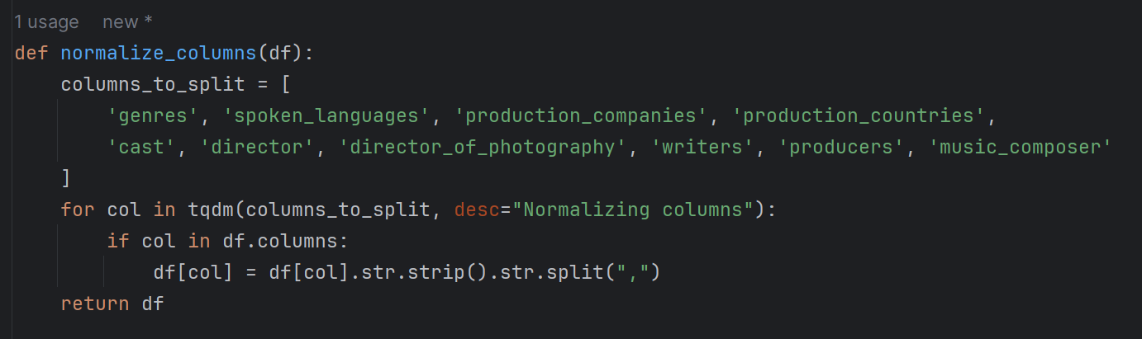

* + Remove duplicate records based on title and release_date.

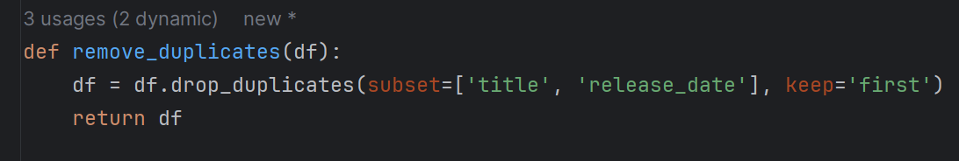 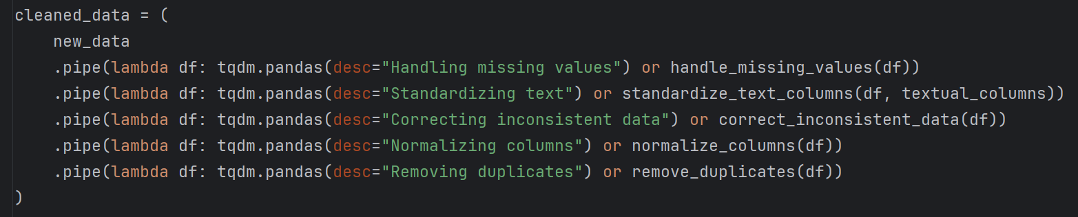

* + Save the cleaned dataset to MongoDB in the MoviesDB.movies collection.

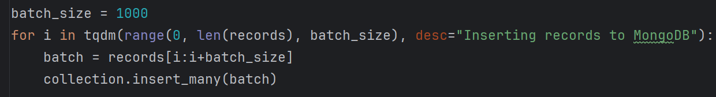

* **Intermediate Output:** A clean and structured dataset in MongoDB.

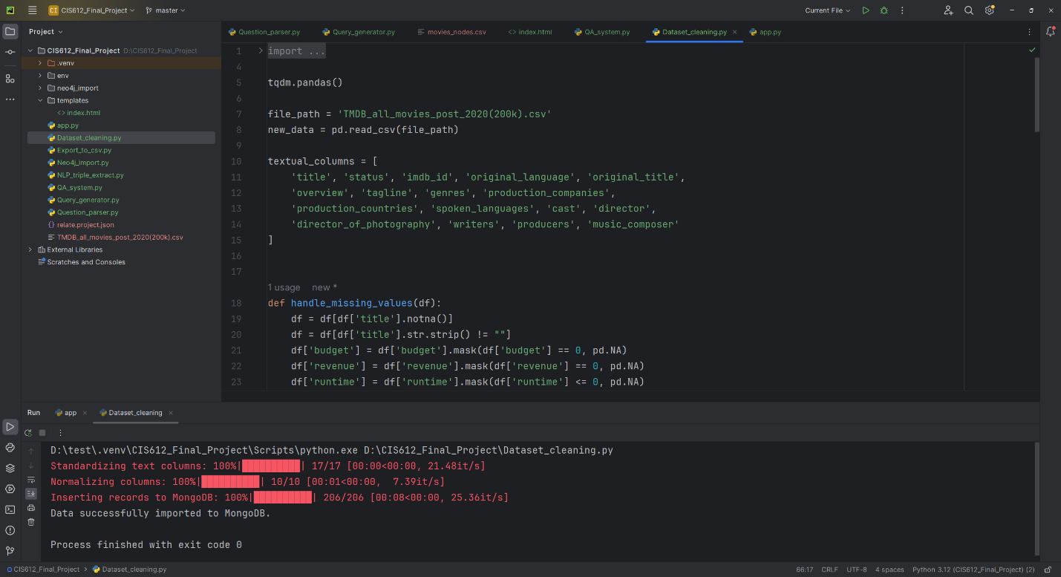

1. **Triple Extraction (NLP_triple_extract.py)**

* **Purpose:** Extracts subject-predicate-object triples from movie overviews using CoreNLP.
* **Steps:**
  + Resolves coreferences in text to improve triple extraction accuracy.

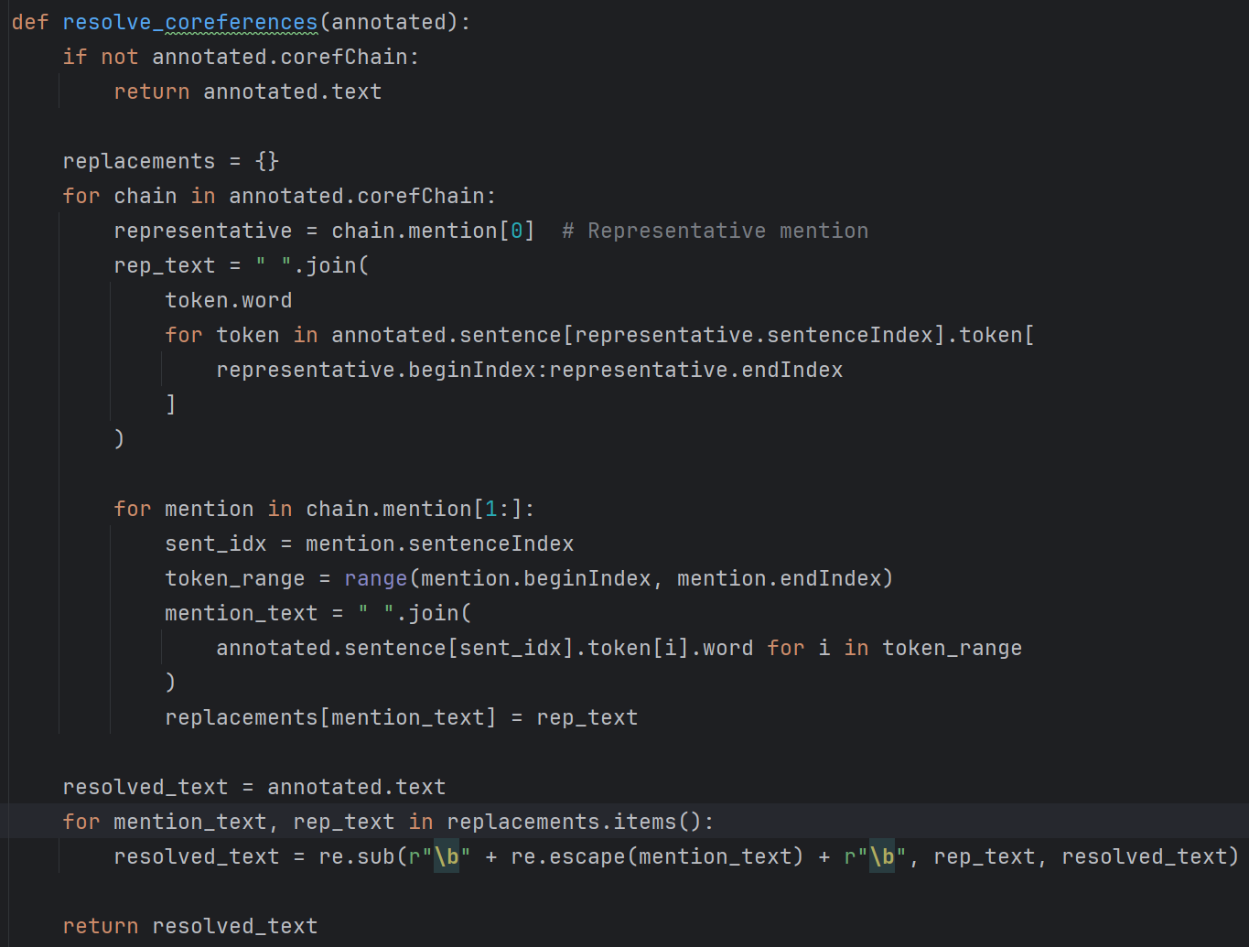

* + Annotates text using CoreNLP and extracts OpenIE triples.
  + Saves triples to MongoDB in the MoviesDB.triples collection.

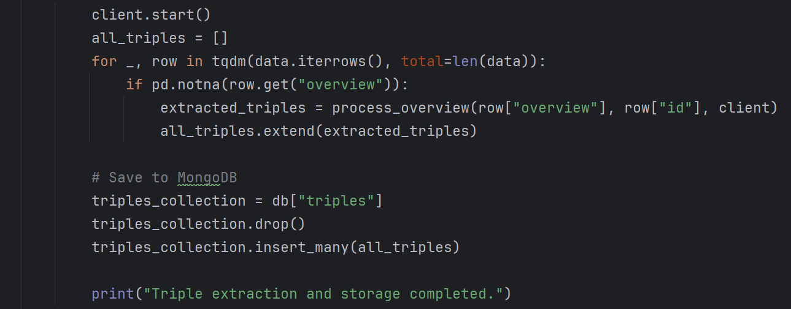

* **Issues Encountered:** Port conflicts with CoreNLP, resolved by dynamically assigning a free port.
* **Intermediate Output:** Triples extracted and stored in MongoDB.

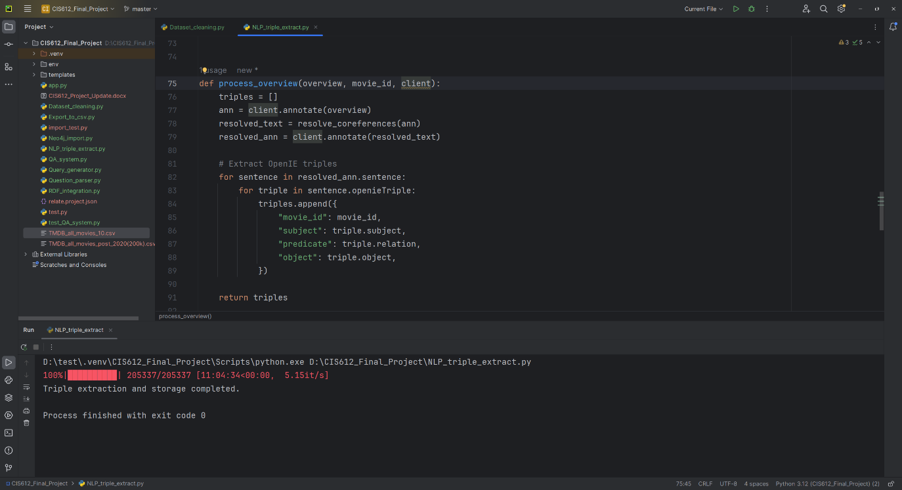

1. **Export to CSV for Neo4j (Export_to_csv.py)**

* **Purpose: Process** cleaned data to CSV for Neo4j import.
* **Steps:**
  + Fetch movies and relationships from MongoDB.

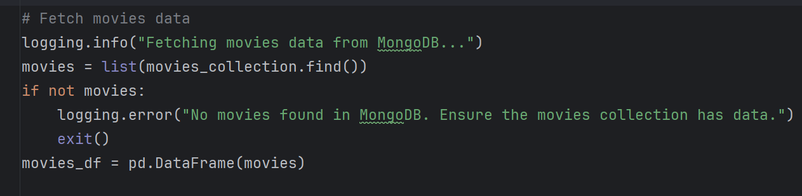

* + Normalize names and generate unique entity IDs.
  + Create node and relationship files for Neo4j import:
    - Entities nodes
    - Movies entities relations
    - Movies nodes
    - Movies triples relations
    - Triples entities nodes
    - Triple relations
* **Issues Encountered:** Data type mismatches in numeric fields, resolved by coercion and filling NaN values.
* **Intermediate Output:** CSV files stored in the neo4j_import directory.

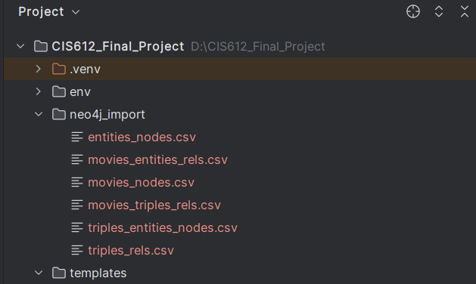

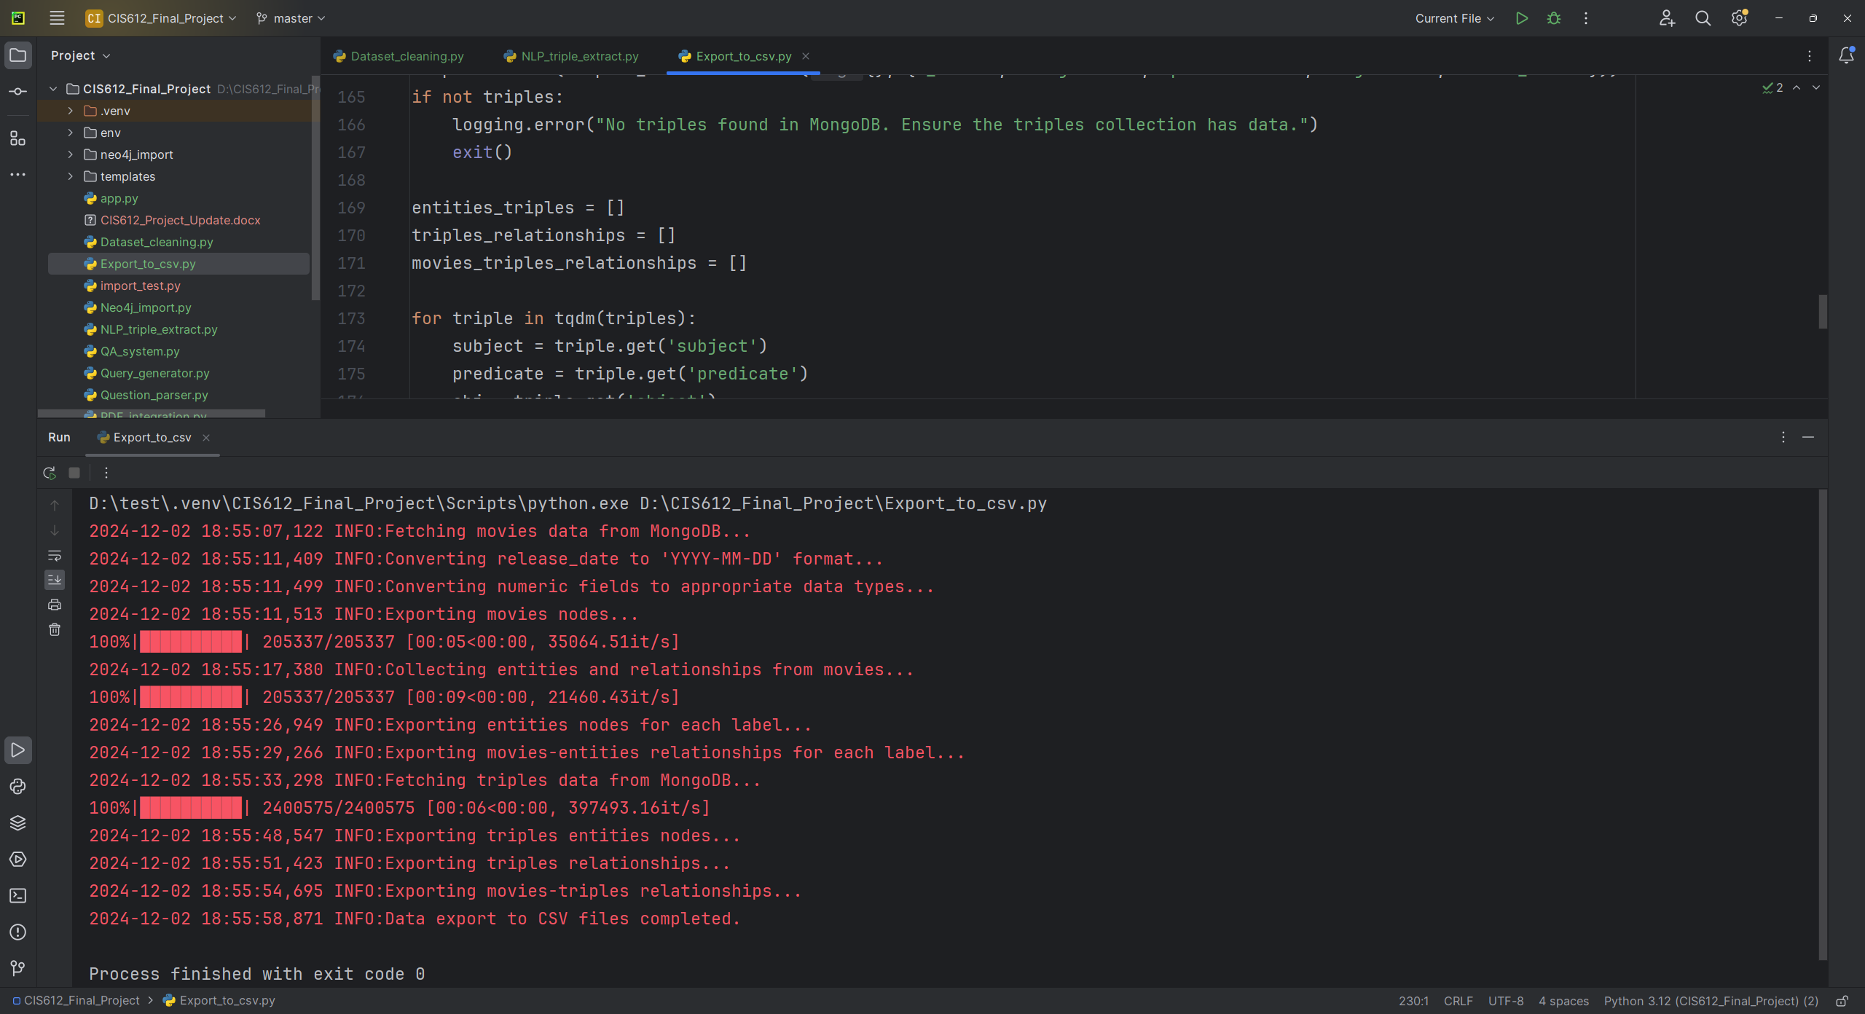

* **CSV files can be used to perform bulk neo4j-admin import:**

**Command:**bin\neo4j-admin database import full ^

--nodes=Movie="D:\CIS612_Final_Project\neo4j_import\movies_nodes.csv" ^

--nodes="D:\CIS612_Final_Project\neo4j_import\entities_nodes.csv" ^

--nodes="D:\CIS612_Final_Project\neo4j_import\triples_entities_nodes.csv" ^

--relationships="D:\CIS612_Final_Project\neo4j_import\movies_entities_rels.csv" ^

--relationships="D:\CIS612_Final_Project\neo4j_import\triples_rels.csv" ^

--relationships="D:\CIS612_Final_Project\neo4j_import\movies_triples_rels.csv" ^

--overwrite-destination=true ^

--verbose ^

neo4j

**Output:**

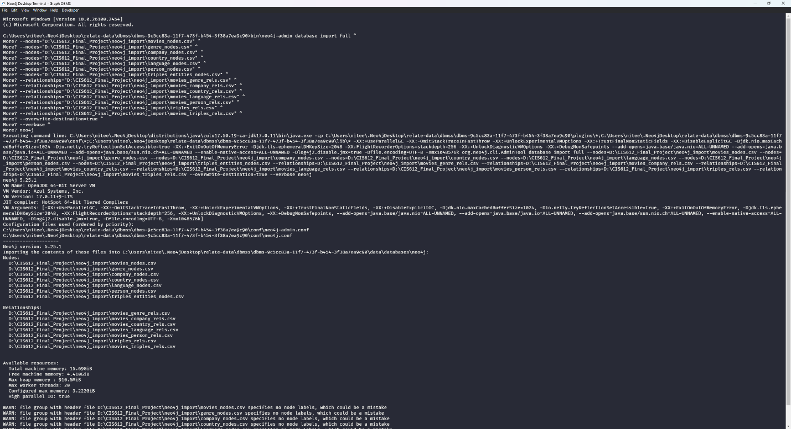

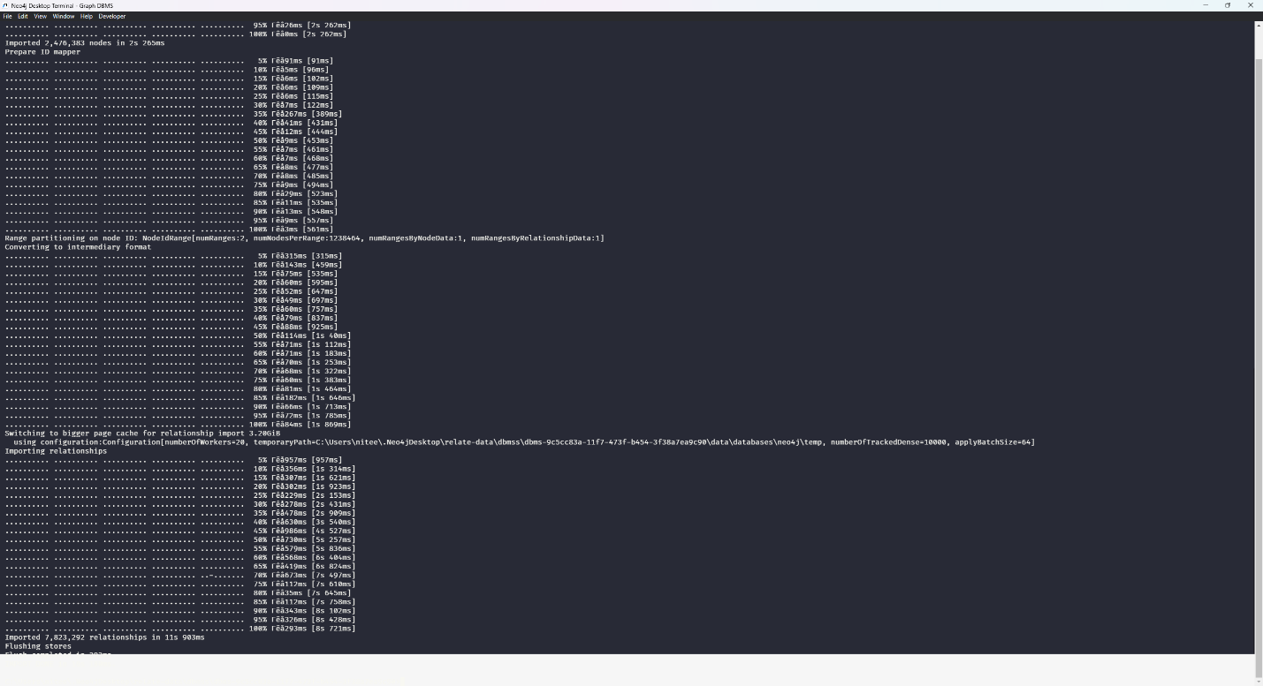

1. **Neo4j Import (Neo4j_import.py -for small data set)**

* **Purpose:** Imports nodes and relationships from MongoDB into Neo4j.
* **Steps:**
  + Creates movie nodes with properties like title, budget, and runtime.

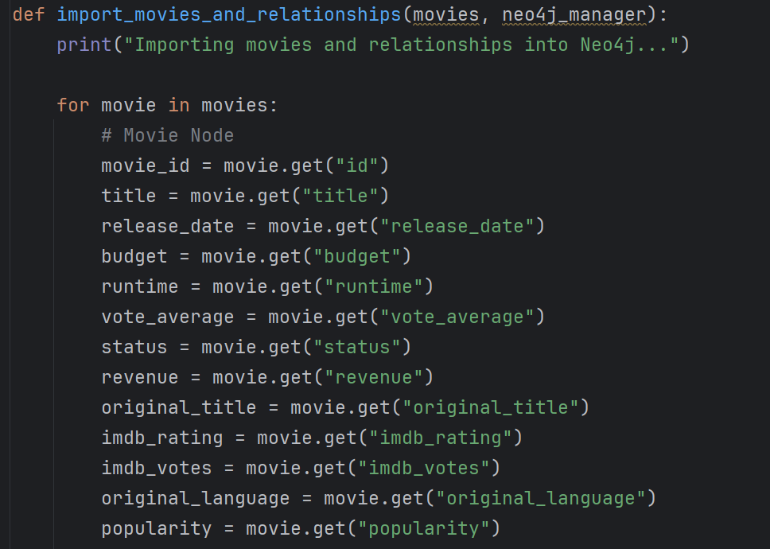

* + Establishes relationships such as DIRECTED_BY, BELONGS_TO_GENRE, etc.

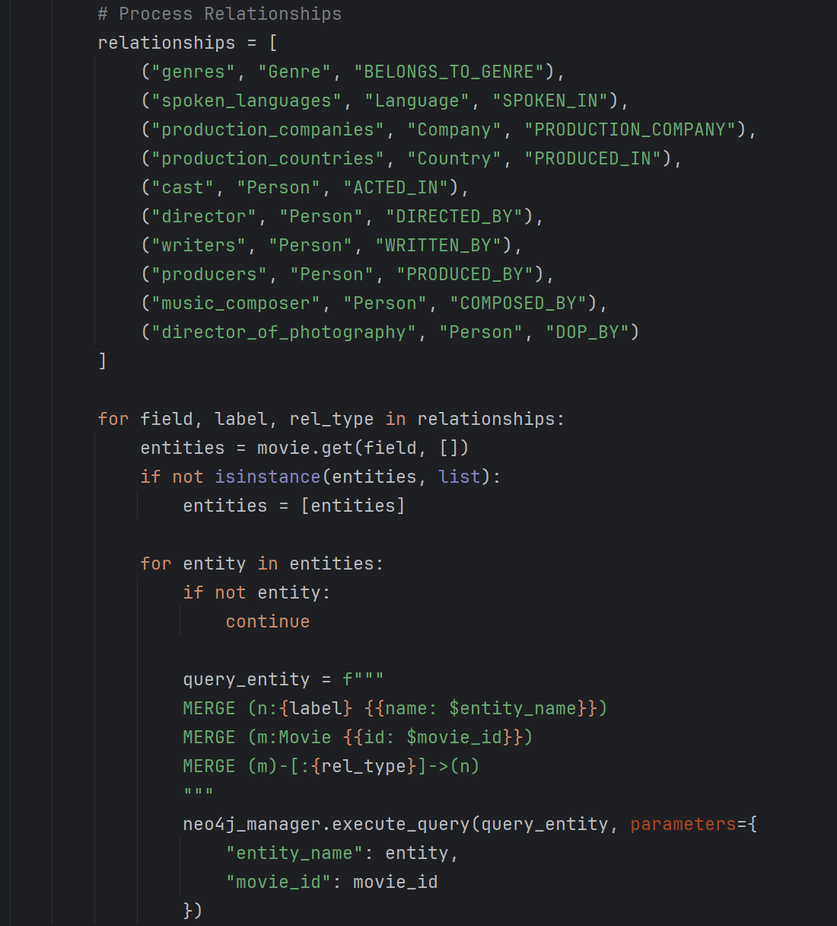

* + Imports extracted triples using APOC procedures.

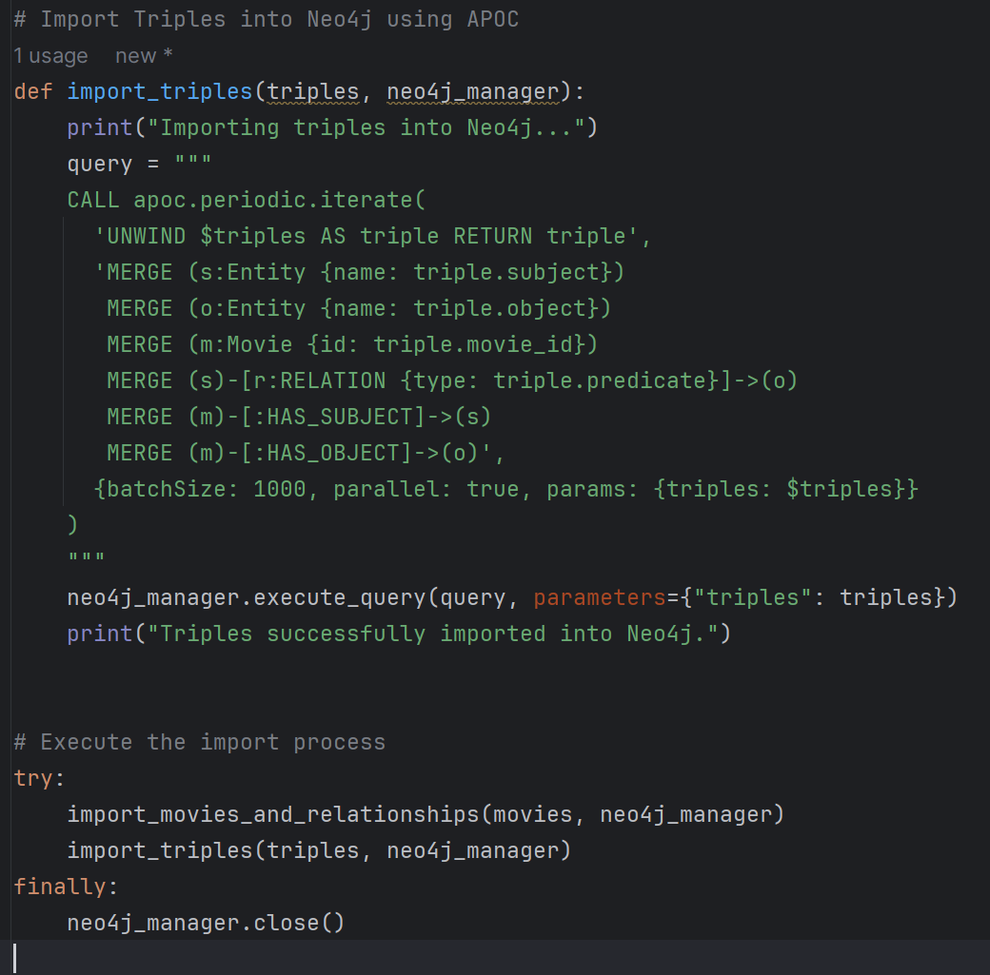

* **Issues Encountered**: Missing data in triples, resolved by skipping incomplete records.

1. **Question Parsing (Question_parser.py)**

* **Purpose:** Determines user intent and extracts relevant entities from natural language questions.
* **Key Features:**
  + Regex-based patterns to identify intents like FindDirector, FindMoviesByGenre.

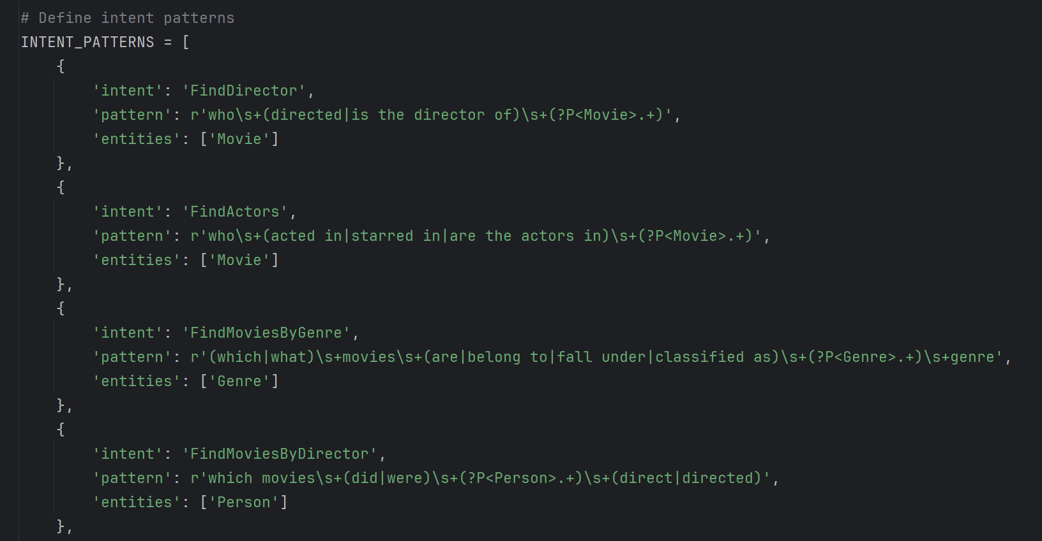

* + Fallback to spaCy NER for entity recognition.

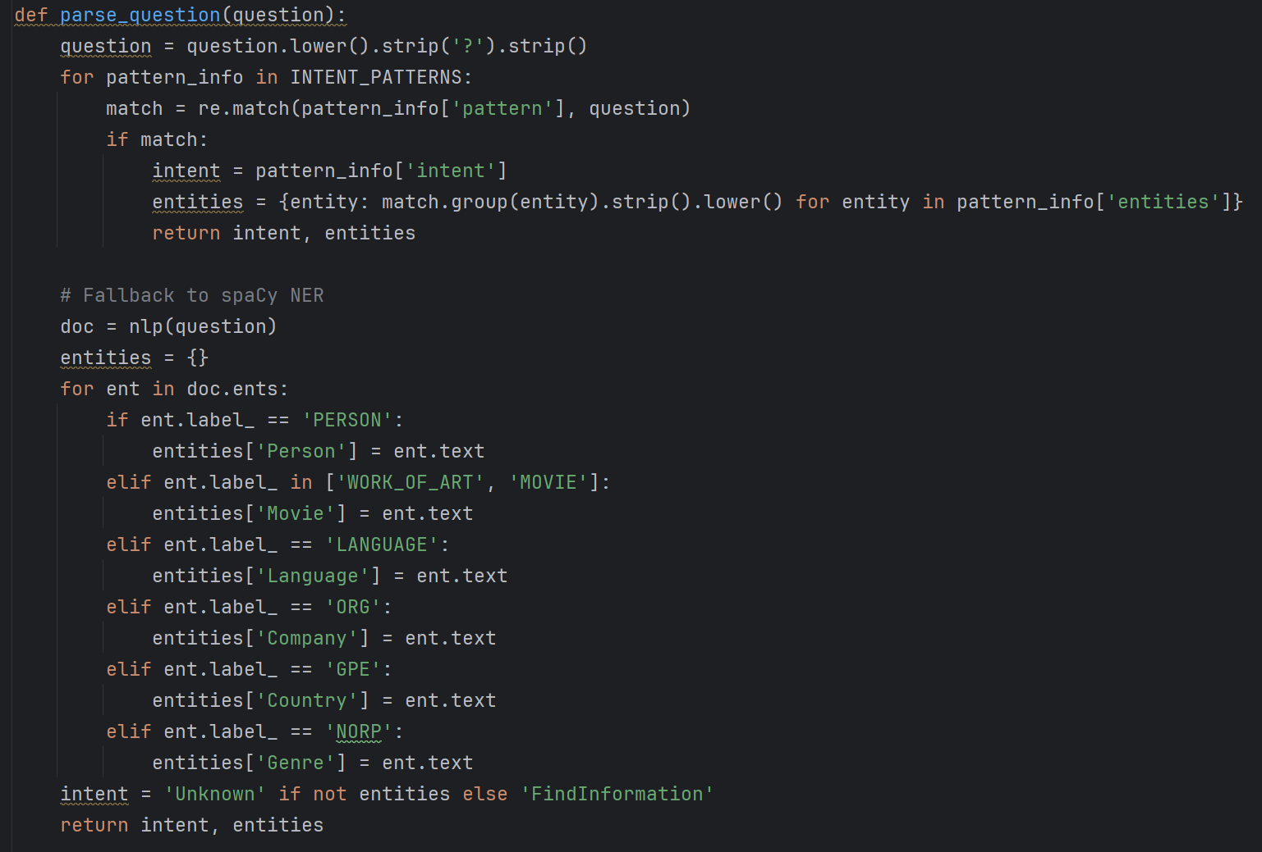

* **Intermediate Output:** Intent and entities (e.g., {'intent': 'FindDirector', 'entities': {'Movie': 'Inception'}}).
  + 1. **Query Generation (Query_generator.py)**
* **Purpose:** Generates and executes Cypher queries based on user intent.
* **Features:**
  + Predefined query templates for intents like FindActors, FindRevenue.

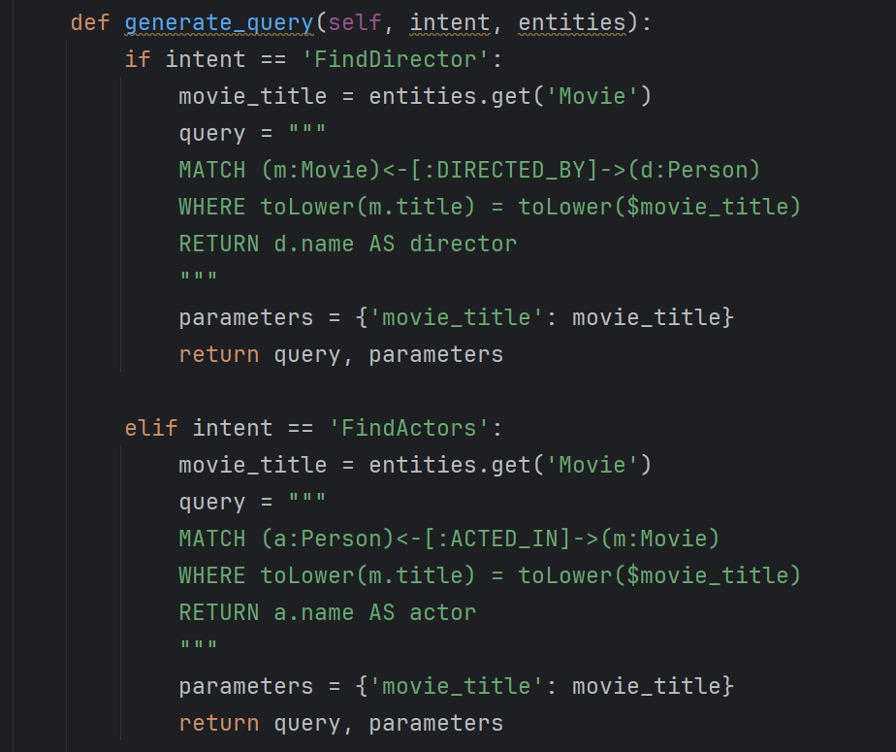

* + Fetches results from Neo4j and formats responses.

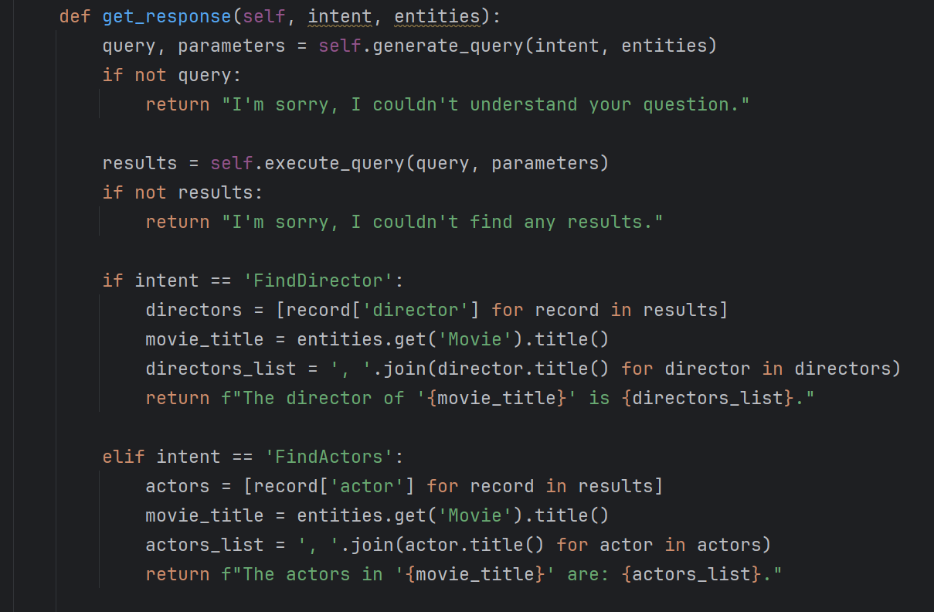

* **Issues Encountered:** Complex queries for trends required optimization by batching and limiting results.
  + 1. **QA System (QA_system.py and app.py)**
* **Purpose:** Provides an interface for users to interact with the system.
* **Modes:**
  + **Command-line Mode (QA_system.py):** Accepts user questions and prints responses.

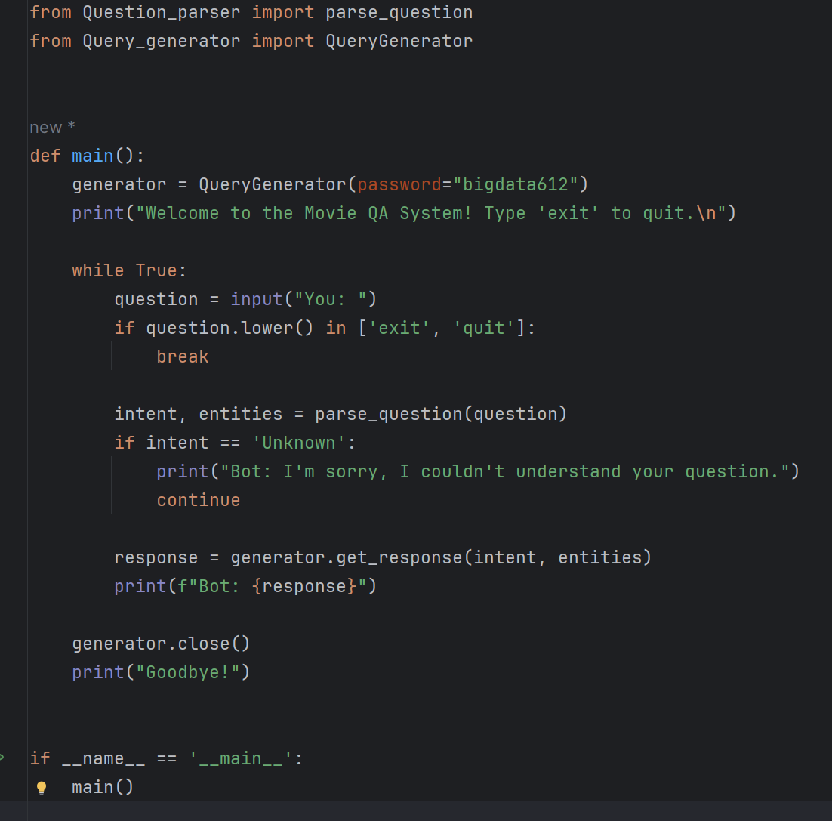

* + **Web Interface (app.py):** Flask application with a form-based UI.

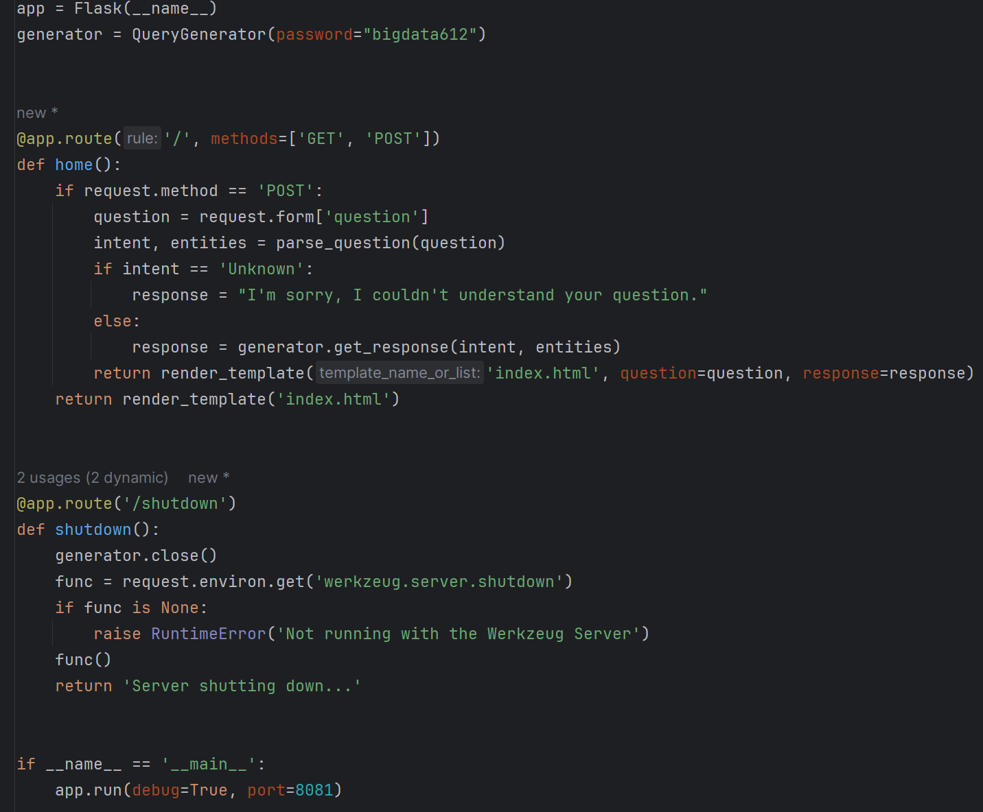

* **Execution:**

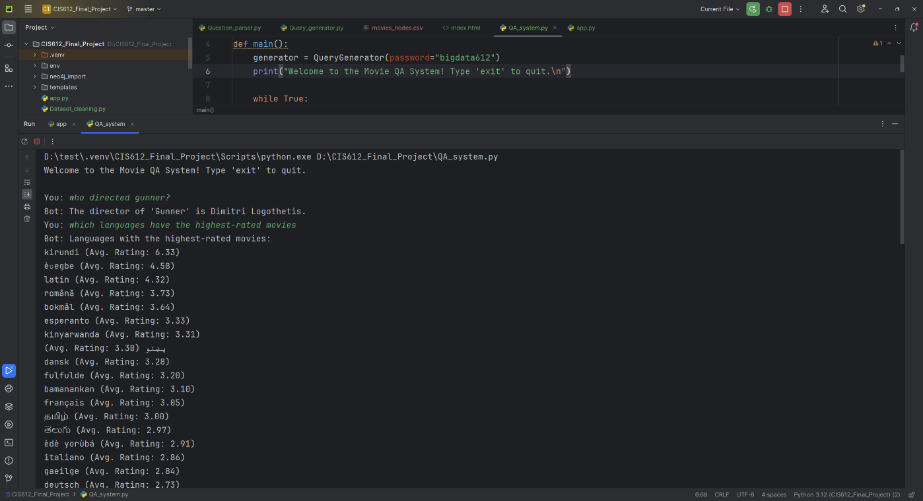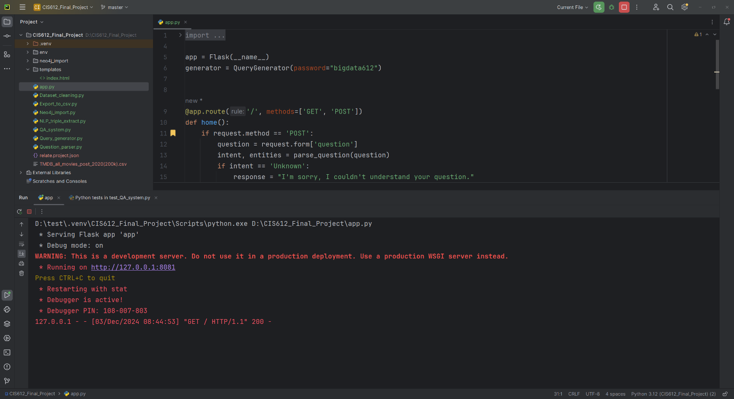

* **Problems and Resolutions**
* **CoreNLP Port Conflicts:** Resolved by dynamic port allocation.

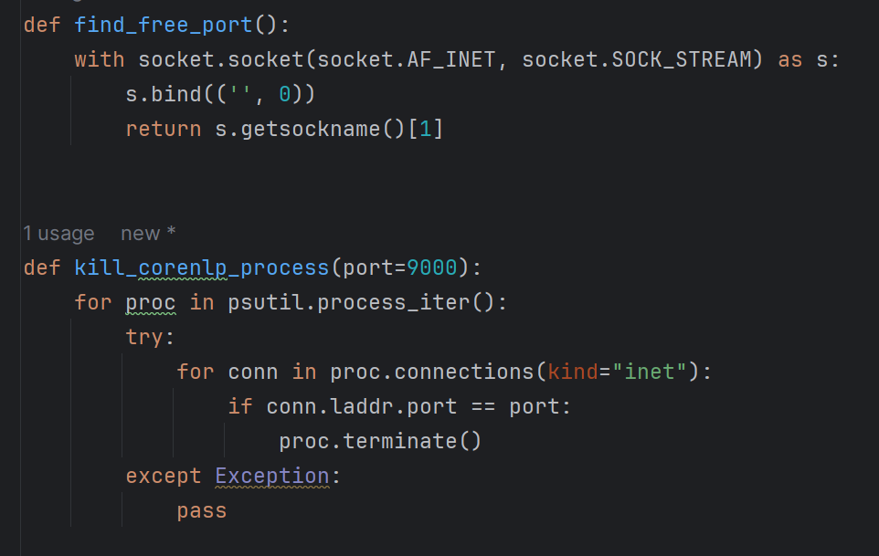

* **Data Type Issues:** Resolved by explicit typecasting in Dataset_cleaning.py and Export_to_csv.py.
* **Neo4j import issue:** Importing a large dataset (~2.2M nodes, ~7.8M relationships, ~211K relationship types) caused bottlenecks.
  + Using Python Driver Import was not feasible due to prolonged import times and performance issues**.**
  + Solution: Neo4j Admin Import due to its ability to import large datasets in under a minute.
* **Building the QA System issue**: We planned to use Neosemantics (n10s) to build the QA system using SPARQL, which would enable semantic queries on RDF data.
  + The newer version of Neo4j no longer supports Neosemantics, limiting our ability to integrate RDF data and execute SPARQL queries.
  + Solution: Adapted the system to use Cypher Queries, leveraging Neo4j’s native query language to design the Q&A functionality.
* **Final Output**
* Cleaned dataset stored in MongoDB.

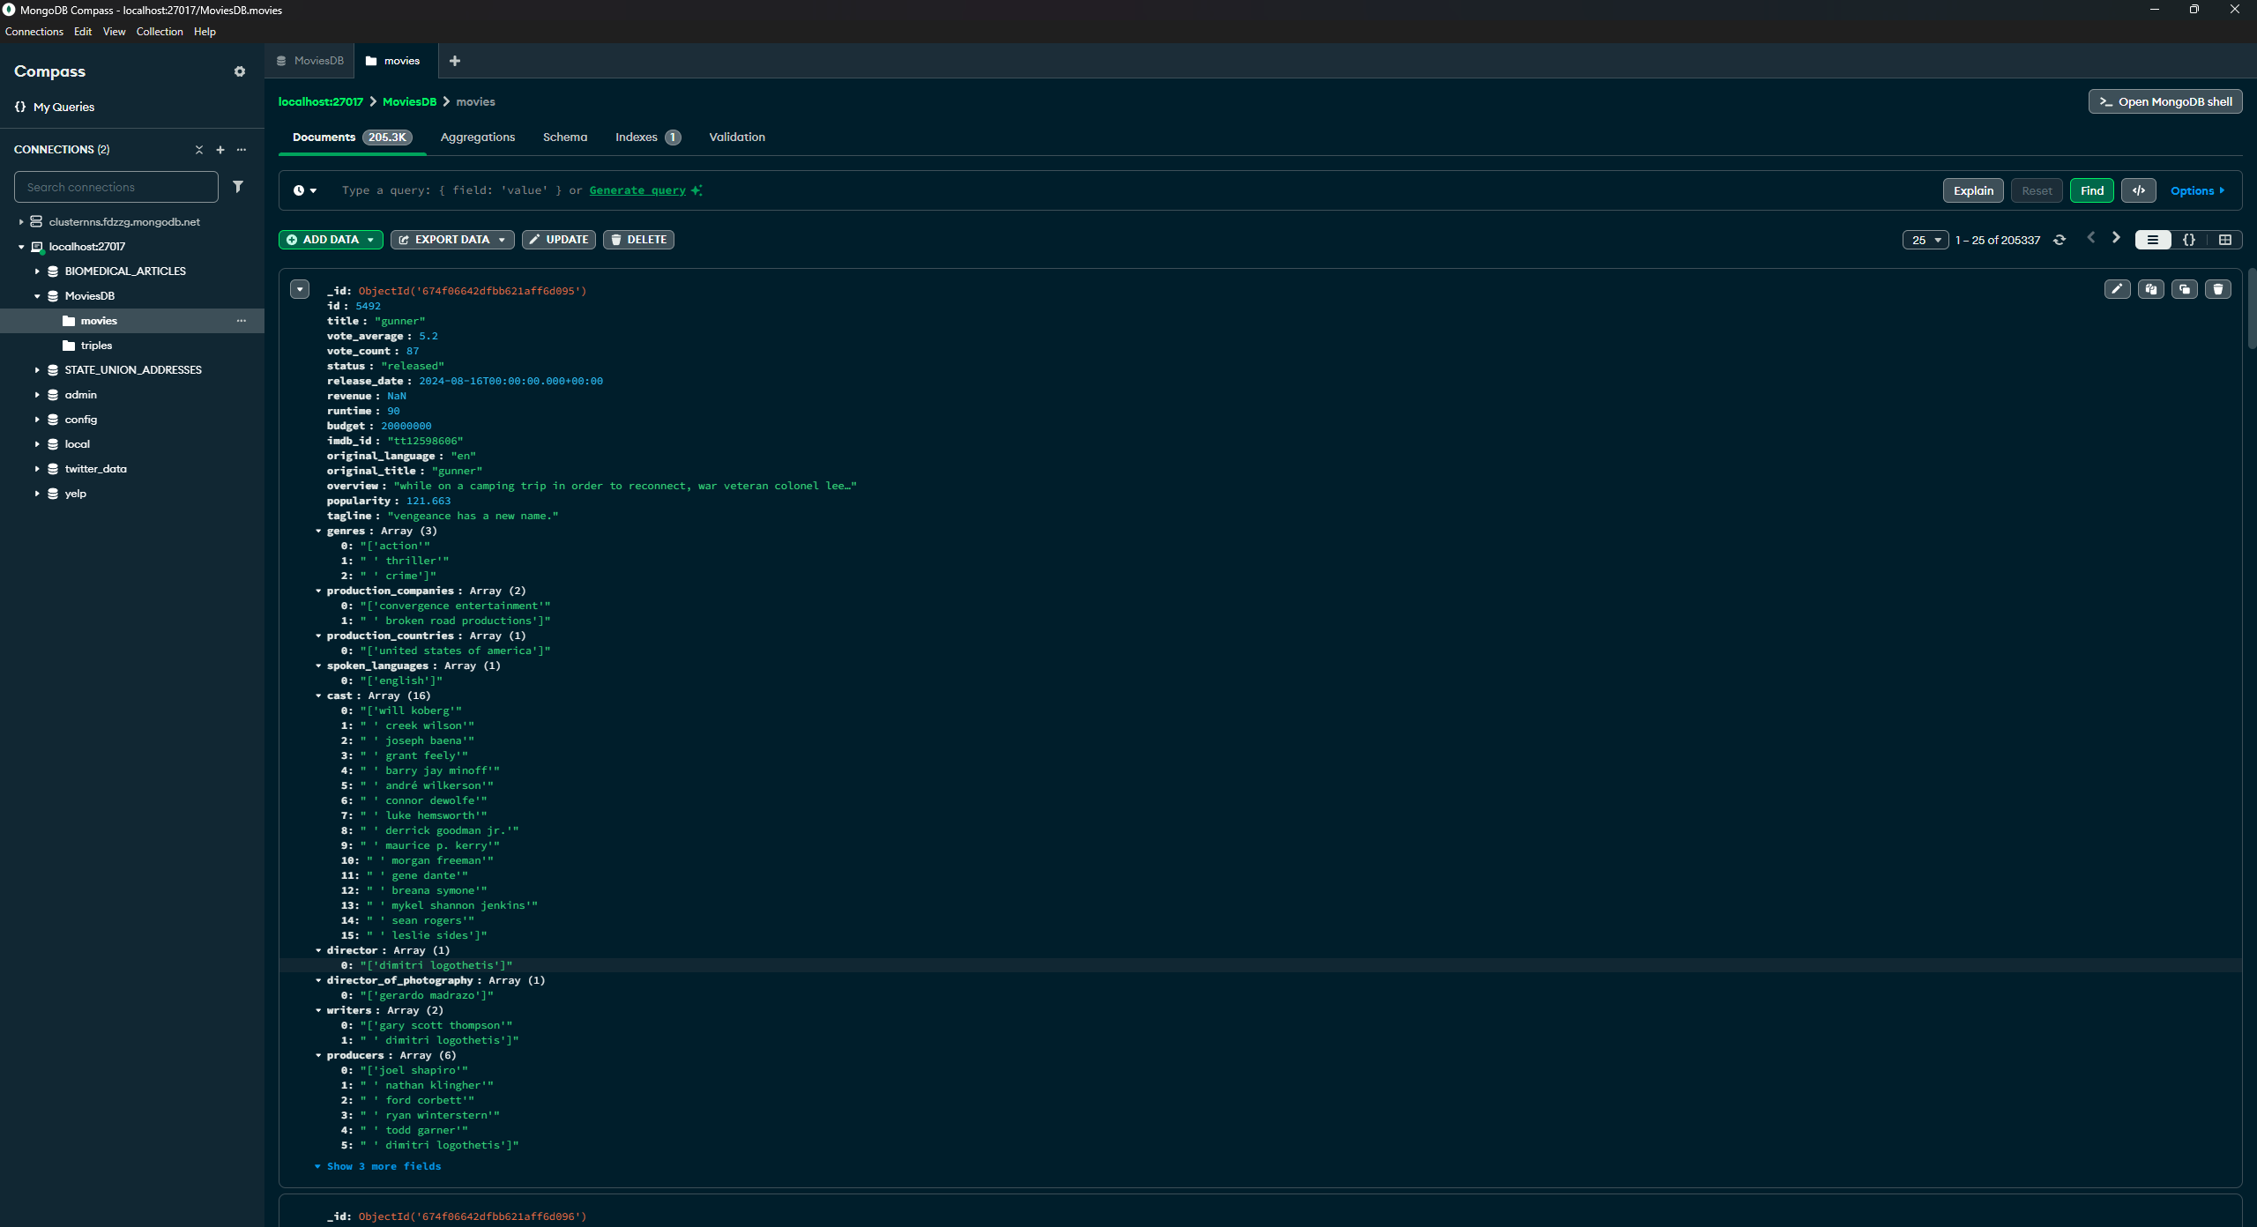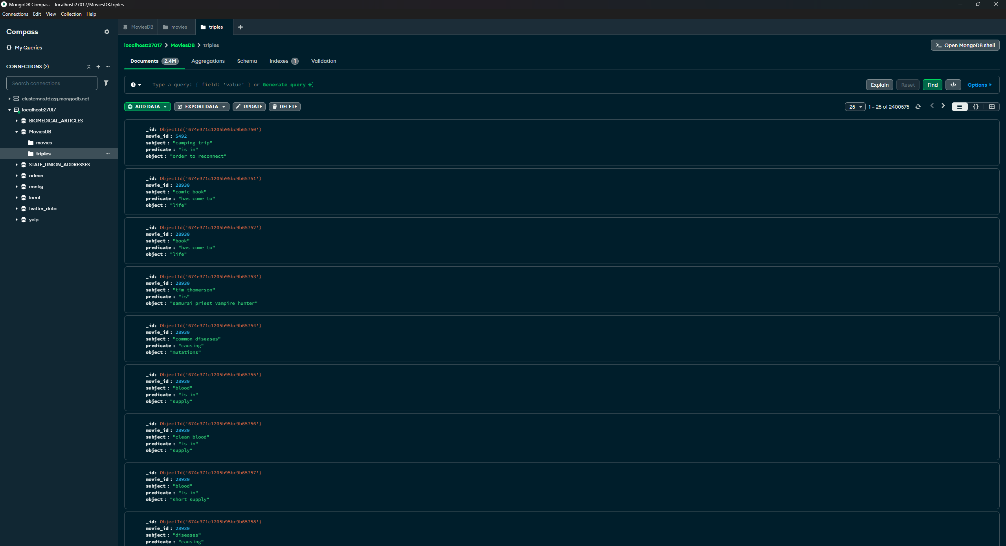

* Knowledge graph nodes and relationships imported into Neo4j.

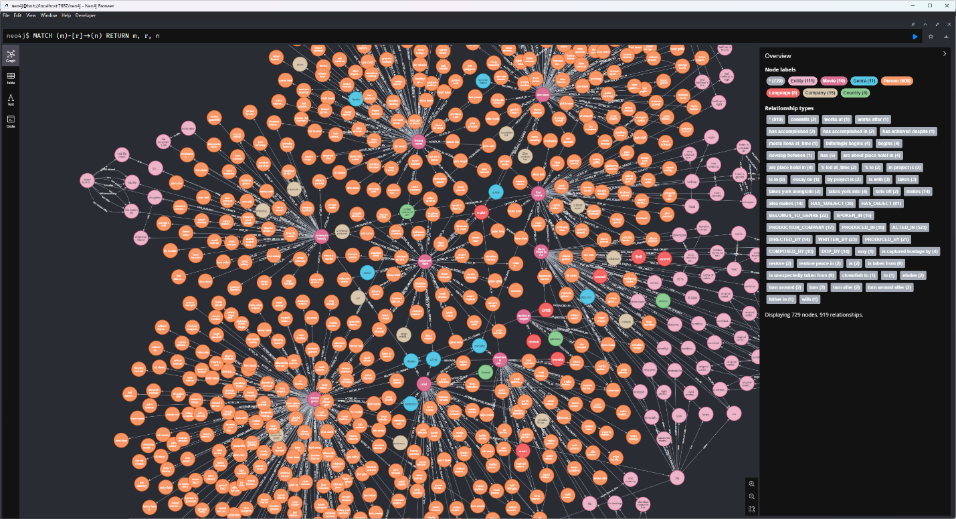

* A functional QA system capable of answering movie-related questions using the knowledge graph.

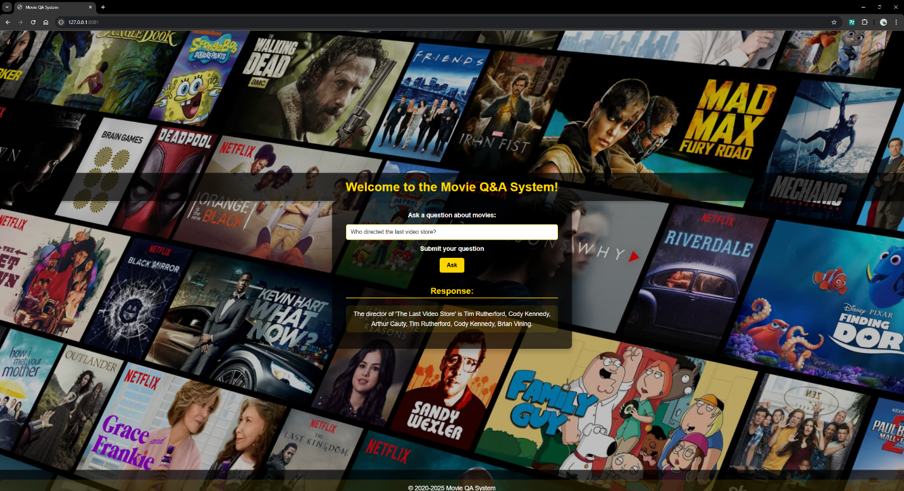

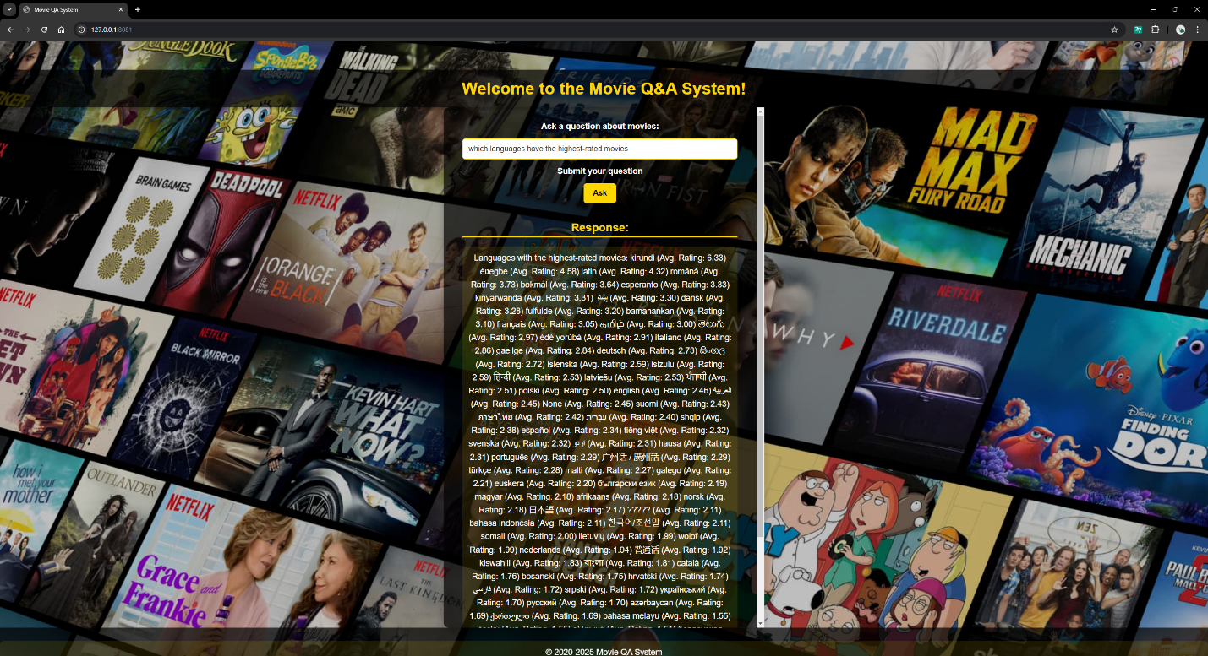

* **Conclusion**
* Successfully integrated NLP and graph databases for robust query handling.
* Enhanced natural language understanding with CoreNLP and spaCy.
* Demonstrated scalability for larger datasets and real-world applications.